Language labs: an overview of the trends

Abstract

Modern language labs offer a wide range of language-learning services and facilities; they therefore require developed administration and state-of-the-art technical infrastructure. Some modern language labs are also involved in innovative research, training services and informational services. This article will present key trends in language-lab development from approximately the 1950’s to the present day. It will therefore describe the history of language-lab advancement, some implications of behaviourism and constructivism, autonomy as a construct, the digital revolution, and modern language-lab services.

1. Introduction: establishing the language lab

Language labs are chiefly used in schools, colleges and universities. They are sometimes also referred to as language resource centres, multimedia labs, centres for language study, language learning centres, interactive media centres, language and technology centres, media centres, open access centres, foreign language centres, open learning centres, open access multimedia centres, self-access centres, individualised language learning centres, independent learning centres, CALL centres/labs, world media and cultural centres, language acquisition centres, and language and computer laboratories.
The perceived need to teach war-zone languages in the Second World War and the subsequent onset of the Cold War brought about, under the aegis of the US Armed Forces Institute and the American Council of Learned Societies, development in methods for teaching foreign languages (Toth 2003). The US Army used the audio-lingual method as early as 1942. By the 1950s language labs began to emerge from the chrysalis of this war-driven language-learning development momentum. Progressive universities spearheaded this metamorphosis by developing impressive inventories of mostly tape-recorded language-learning materials and increasingly inviting infrastructures in which to utilize these materials. However, in retrospect, one might question why language labs had not become widespread earlier. In the US for instance, in 1913 Diamond-Disc players were beginning to be sold, commercial radio came into operation in 1920, the first commercial sound film with spoken dialogue was achieved in 1927, the first magnetic tape recorder was demonstrated in Berlin in 1935 and in 1949, 7-inch 45rcm micro-groove vinylite records were introduced (Schoenherr 2005).
Language labs established themselves as centres of language learning contemporaneously during the rock and roll years of the 1950s and 1960s; technological breakthroughs during this period were catalysed by the enticing rewards of musical entertainment and language labs were on the whole fortuitous beneficiaries of these market-orientated advancements. Key achievements during this period seem analogous in merit with recent 2001-2007 developments in portable music players. They included the transistor portable radio (1954), the stereo LP (1958), the compact audiocassette, the first home Sony video tape recorder (1963), and Dolby Noise Reduction (1968). The International Association for Language Learning Technology (IALLT) was established in 1965; it is a professional organisation that attempts to provide leadership in the development, integration, evaluation and management of instructional technology for the teaching and learning of language, literature and culture.

2. Behaviourism and constructivism

Although recording technology during the 1970s and 1980s continued to progress, language-lab approaches apparently began to fall out of favour (Garcia and Wolff 2001, Davies et al. 2005). Significant 1970’s technology comprised the 4-hour VHS tapes (1977), the Sony Walkman audiocassette player (1979) and the video camcorder (1980). The reason for this perceptible loss of self-efficacy for language labs most likely had its roots partly in the methodological move away from structural approaches to language learning, to a flurry of novel, outwardly sturdy but often transient techniques for second learning acquisition. Well-known such approaches include: The Silent Way (Gattegno 1972); Total Physical Response (Asher 1969); Community Language Teaching (Curran 1976); Suggestopedia (Lozanov 1978); Communicative Approaches (Brumfit and Johnson 1979, Widdowson 1978, Yalden 1983); The Natural Way (Krashen and Terrell 1983).
Even though behaviourist theory with its asserted filling-the-blank-slate (Beatty 2003, 94), rote-learning and repetitive drilling (pejoratively known as ‘drill and kill’ Warschauer and Healey 1998) came under a ‘cognitive’ attack from Chomsky in 1964, strangely it is still discussed and compared to the now trendy and dominant constructivist model in modern CALL literature. Beatty (2003, 91) for instance attempts to elucidate how constructivism differs radically from behaviourism suggesting that learning is a process by which learners construct new ideas or concepts by making use of their knowledge and experience; the learner ‘has greater control and responsibility over what he or she learns’ (Beatty 2003, 91). Beatty (2003, 99-100) also asserts that collaboration is an important activity in CALL as it encourages social skills and thinking skills and it mirrors the way in which learners often need to work once they leave the academic setting. There is also an imposing and compelling literature base that discusses the benefits of collaboration (e.g. Candlin 1981; Chaudron 1988; Ellis 1998; Nunan 1992). Modern language-lab Web pages also often refer to the concept of taking control and responsibility over learning; for instance in the Directed Independent Language Study programme on the Yale University’s Center for Language Study Web page, it is stated that students ‘must be self-directed and self-disciplined, and they must be willing and able to assume full responsibility for their learning’.

3. Autonomous learning as a construct

Autonomous learning is now a language-lab buzzword; it has therefore become a feature of self-access centres (or language labs) (Benson 2001, 114). For instance, the University of Hull’s Open Learning Centre states that students can work independently on language learning in a comfortable and well-resourced environment or the University of Nebraska-Lincoln’s Modern Languages Lab maintains that lab work is of an individual, independent nature and that instructors ‘may check’ lab work. Moreover, Davies et al. (2005, 10) state that with regard to complete commercial language courses (courseware) to be used online, facilitated through a language lab, the general consensus of opinion is that one principle of usage should reflect the need to allow the learner to proceed from dependence to autonomy in any learning activity. Benson (2001, 35) states that recent research in the field of autonomy has drawn freely on research in the constructivist tradition within which works of Kelly (1963); Barnes (1976), Kolb (1984), Vygotsky (1978) have been especially influential. Benson (2001, 8) maintains that autonomous learning is learning in which the learners themselves determine the objectives, progress and evaluation of learning. It also has a robust literature base (e.g. Breen and Candlin 1980; Little 1997; Riley 1988). Benson (2001, 22-46) holds that the concept of autonomy in language learning has influenced and has been influenced by a variety of approaches within the field (e.g. Kilpatrick 1921; Freire 1974; Rogers 1969). Yet, Benson (2001), who maintains a comprehensive online bibliography on autonomy, in his book on autonomy in language learning is somewhat tentative when he summaries that:

We still know relatively little about the ways in which practices associated with autonomy work to foster autonomy, alone or in combination, or about the contextual factors that influence their effectiveness. We are also unable to argue based on empirical data, that autonomous language learners learn languages more effectively than others, nor do we know exactly how the development of autonomy and language acquisition interact. (Benson 2001, 224)

Personalised learning is about tailoring education to the individual need, interest and aptitude so as to ensure that every pupil achieves and reaches the highest possible standards (Becta 2006a, 4); it is therefore closely associated with autonomous learning in which the learners themselves determine the objectives, progress and evaluation of learning (also held by Condie and Munro 2007, 6-7). The Oxford University Language Centre Lambda Project for instance is in effect developing personalised learning when it investigates how learners can best maintain and develop their language skills independently. Moreover, the British Educational Communications and Technology Agency (Becta) in a plethora of recent publications (e.g. Becta 2006b; Becta 2007a; Becta 2007b), seems to be propagating the construct of personalised learning; yet personalised learning might also be mutating the learner-teacher bond. The Condie and Munro (2007, 6-7) report, for instance, a major study on the impact of ICT in schools, commissioned by the Department for Education and Skills (DfES) and Becta in the UK, is hesitant with regard to the impact of personalised learning on classroom relationships:

A persistent theme in the literature is the extent to which ICT can make the learning experience more personalised, more targeted at the needs of the individual learner. Combinations of technology and applications give greater choice in relation to what, when and where to study, selecting according to interests, learning styles and preferences and need. Such systems can give the pupil more autonomy and independence with regard to learning and a range of sources to draw on. This can be unsettling for some teachers and may well change the dynamics of the pupil-teacher relationship. There is little in the literature on the potential impact on relationships in the classroom as schools develop e-capability and use ICT to support the learning process more widely. Condie and Munro (2007, 6-7)

Appertaining to the impact of ICT on attainment, Condie and Munro (2007, 4) also appear tentative when stating that ‘at present the evidence on attainment is somewhat inconsistent, although it does appear that, in some contexts, with some pupils, in some disciplines, attainment has been enhanced’.
Nonetheless; Becta (2006b, 16) states with regard to personalised learning spaces that ‘the potential to enhance the learning experience is immense’; Becta (2007a, 1) maintains that ‘personalised learning is a major goal in both the proposed 14-19 reforms’ and ‘the embedded use of ICT supports and delivers personalised learning’; DfES (2006, 5) holds that it is an educational priority to ‘establish a clear vision of what personalised teaching and learning might look like in our schools in 2020; Condie and Munro (2007, 6-7) state that the UK Government’s e-strategy sets the expectation that by 2008 every pupil should have access to a personalised online learning space; Becta (2007b, 5), with regard to ICT and e-learning in further education, however, emphasises that the use of ICT to personalise learning is ‘at an early stage and still has a long way to go’.
In light of the above discussion regarding autonomy/personalised learning, modern language labs may be faced with a possible contentious issue: is learner autonomy (or personalization of learning) in practice a sufficiently workable construct for justifying the pursuit of the ‘bleeding edge’ (Beatty 2003, 71) new tools in ICT or are the new ICT tools an appropriate cost-effective apparatus for developing the possibly terminologically and conceptually confusing (Benson 2001, 1) construct of learner autonomy?

4. The digital revolution and self-access

The onset of the digital revolution in the early 1980s with its CD-ROMs (1985), DVD players (1996), MP3 players (1998), Apple Computer iPods (2001) and the comprehensive advancement in computer hardware/software, reliable Internet services and wireless technology devices provided new tools for language labs.
Benson (2001, 114) argues that historically self-access centres (or language labs) have occupied a central position in the practice of autonomy and many teachers have come to the idea of autonomy through their work in them. A self-access centre is essentially a language lab in which learning resources such as audio, video and computer stations, audio/videotapes, computer software and printed materials are made directly available to learners. Examples of some self-access centres can be found at the University of Cambridge, the Chinese University of Hong Kong, the City University of Hong Kong, the University of Hull Language Institute, Middlesex University, University of Colorado-Boulder, Yale University, Oregon State University, Indiana University, University of Albany, University of Nebraska Lincoln, University of Houston, Oxford University, Michigan State University, Sussex University, Princeton University, Purdue University, Ohio State University, Ohio ESL, Carnegie Mellon University, John Hopkins University, Rice University, University of Oregon, Washington University, Hawthorne-Melbourne University.
However, whether or how the users of such self-access centres use centre materials in a way that enables them to construct new ideas and so take control over their own learning (autonomy/constructivism) or drill and repeat (behaviourism/audio-lingual) seems less relevant than whether there is any measurable outcome for the learner or tutor. Moreover, it could be argued that structuralism is on the rise as a result of the numerous ESOL interactive Internet exercises that have become available on well-known CALL sites; many such exercises, at least at the moment, seem to be narrowing foreign language teaching to mainly structural grammar and vocabulary (Alexander 2006, 2007).

5. Language-lab facilities

Modern language labs offer an extensive and growing range of services to users. Most of the services relate to offering a variety of modes of learning foreign languages and developing a corresponding assortment of materials for such languages. As a result, such language labs often have a developed administrative and state-of-the-art technical infrastructure. Another area that modern language labs are widening pertains to innovation and development. The Center for Language Study at Yale University for instance engages in professional development, provides funding for research or attempts to strengthen language programmes taught at the University. The Cambridge University Language Centre on their research and development e-link maintains that the ‘language learning and teaching activities of the Language Centre are underpinned and informed by relevant research in second language acquisition and educational technology’. Princeton University Language Resource Center receive support from the Educational Technologies Center and so build and maintain tools for teaching and research.

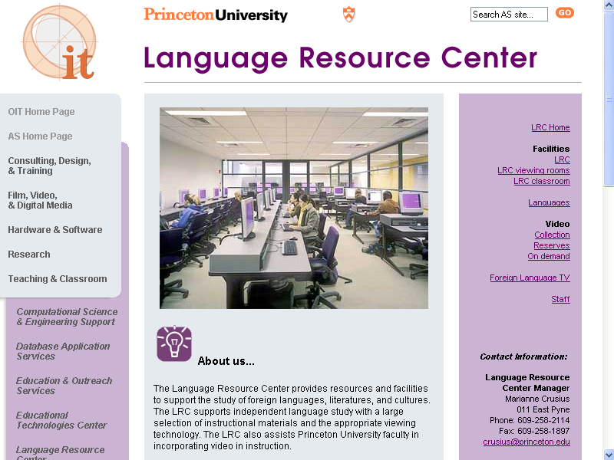

Screenshot 1 Princeton University Language Resource Center

Screenshot 1 presents an example of a language-lab homepage offering extensive services. The Language Resource Center at Princeton University states that it provides ‘resources and facilities to support the study of foreign languages, literatures, and cultures’; moreover it also states that it supports independent language study and assists Princeton University faculty in incorporating video into instruction.

5.1 Language-learning materials’ related

Language labs offer a broad range of learning materials and modes of language learning. This range includes the use of: CDROMS (Chinese University of Hong Kong), English newspapers (Sussex), general language links for students (used at Sussex), video conferencing (Michigan State), MP3s (Colorado-Boulder), language learning centre blog (current awareness for students, used at Sussex), multimedia library (Colorado-Boulder), materials catalogue (Colorado-Boulder), self-access and independent learning (City University of Hong Kong), language Podcasts (Washington), self access services (Middlesex), film, video and digital media (Princeton), language buddies (Victoria University of Wellington, ‘Language Buddies’ are native speakers of different languages who help each other improve language skills), audio materials listing (Indiana), international television broadcasts (Indiana). Language labs also usually offer a variety of online language links; the following labs offer a wide range of Internet language links: University of Colorado-Boulder, Indiana University, Languages On-Line (Indiana University), University of Nebraska-Lincoln, University of Houston, Washington University, John Hopkins University, Cambridge University, Oxford University, Michigan State University, Princeton University, Ohio ESL, Rice University, Yamada Centre, Washington University.
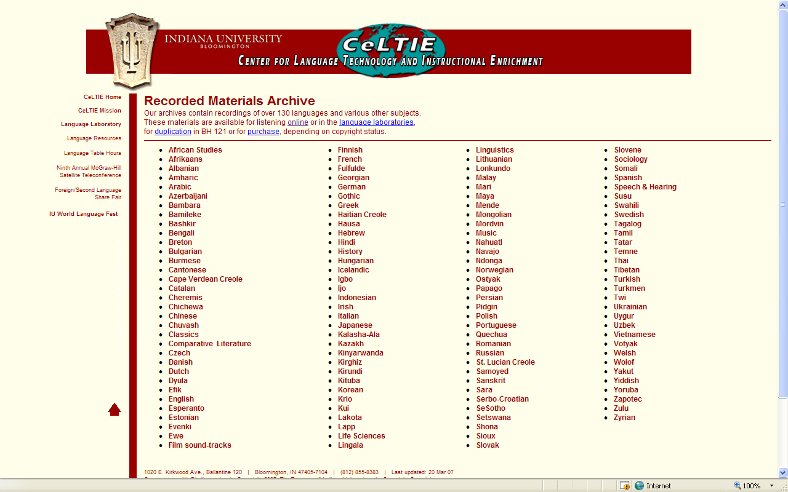

Screenshot 2 Online language materials at Indiana University

Indiana University, in screenshot 2, provides archives of over 130 languages available for listening online or for use in language laboratories.

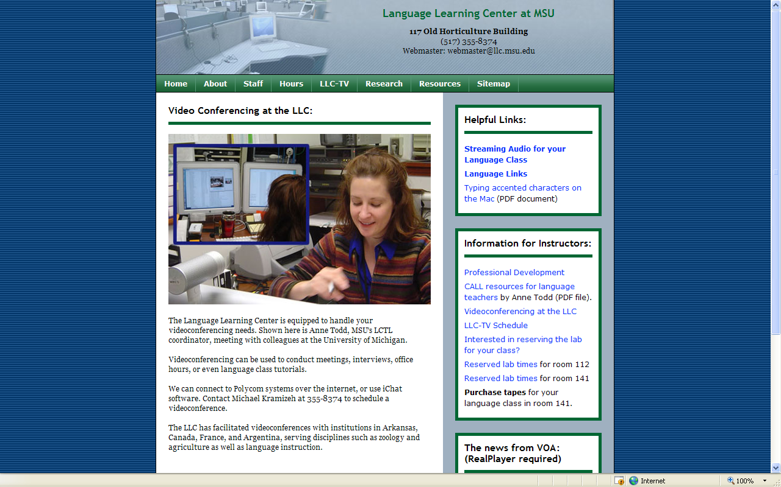

Screenshot 3 Videoconferencing

Screenshot 3 provides an example of the videoconferencing facility at the University of Michigan’s Language Learning Center. Screenshot 4 below explains how the University of Washington’s Language Learning Center uses Podcasts with up-to-date content for language learning.

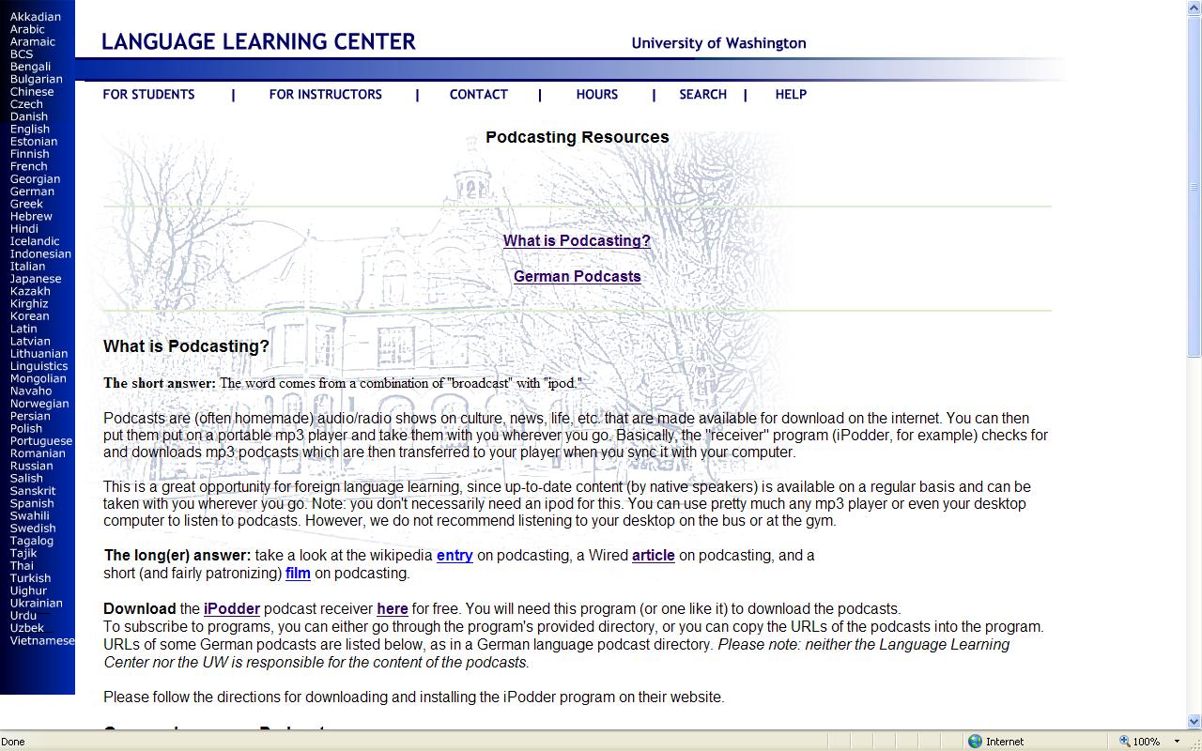

Screenshot 4 Language Podcasts

5.2 Developmental-related

Some language labs provide a gamut of innovative testing and training services for students and staff. Some of these services include: professional development (Yale), e-testing services for students (Oxford), directed independent language study for students (Yale), technology training for staff and students (Albany), foreign language technology certificate for staff and students (Colorado-Boulder), language classes for staff and students (Colorado-Boulder), consulting, design and training (Princeton).

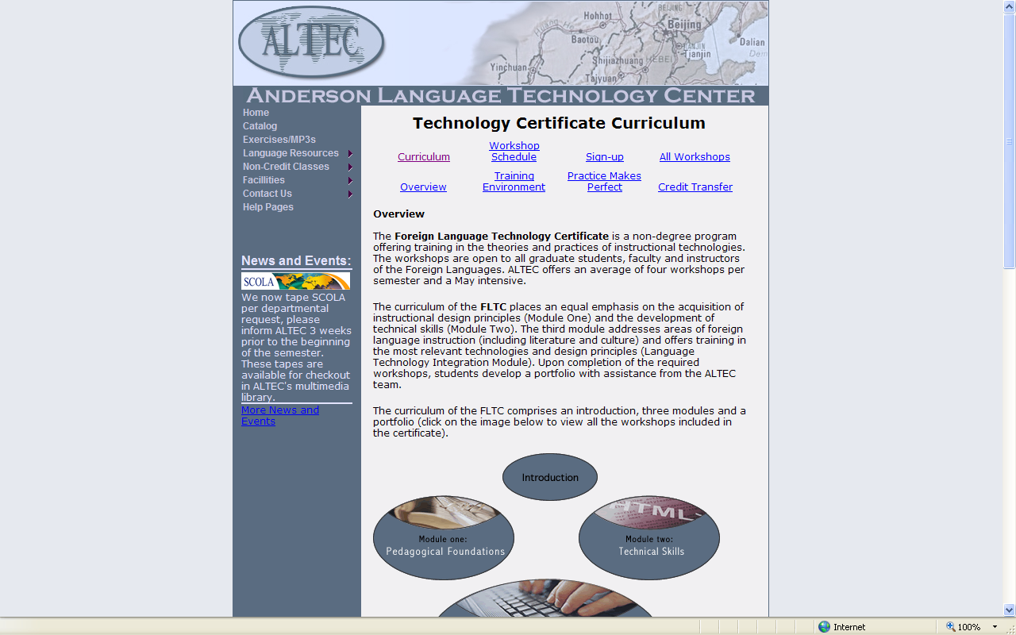

Screenshot 5 The Technology Certificate Anderson Language Technology Center

The Foreign Language Technology Certificate presented in screenshot 5 at the University of Colorado-Boulder offers training in the theories and practices of instructional technologies. The workshops are open to all graduate students, faculty and instructors of the Foreign Languages.

5.3 Administrative related

Modern language labs require developed administration; some typical administrative tasks comprise responding to a faculty/staff helpdesk (Albany), a student helpdesk (Albany), a Web helpdesk (Middlesex) or a technology help link (Colorado-Boulder). Other duties involve presenting lab staff (Yale), providing materials purchase information (Indiana), submitting recorded materials (Indiana), giving information about contact and location (Yale) and adhering to lab opening hours (Colorado-Boulder). Another important administrative undertaking pertains to audio-tape check-out (Indiana), tape drop-off and pickup (Nebraska-Lincoln), lab check-in and checkout (Nebraska-Lincoln) and general lab scheduling.

5.4 Technology-related

Modern language labs also need to have a developed and functional technology infrastructure; some of the technology considerations include: WebCT (Houston), lab services (Houston), lab equipment and services (Houston), PC classrooms (Colorado-Boulder), video viewings in class (Yale), Mac classrooms (Colorado-Boulder), studio recordings (Yale), technology services (Yale), media conversion and duplication (Yale), software and hardware (Albany), technical related links (John Hopkins), equipment available for short-term use (Michigan State).

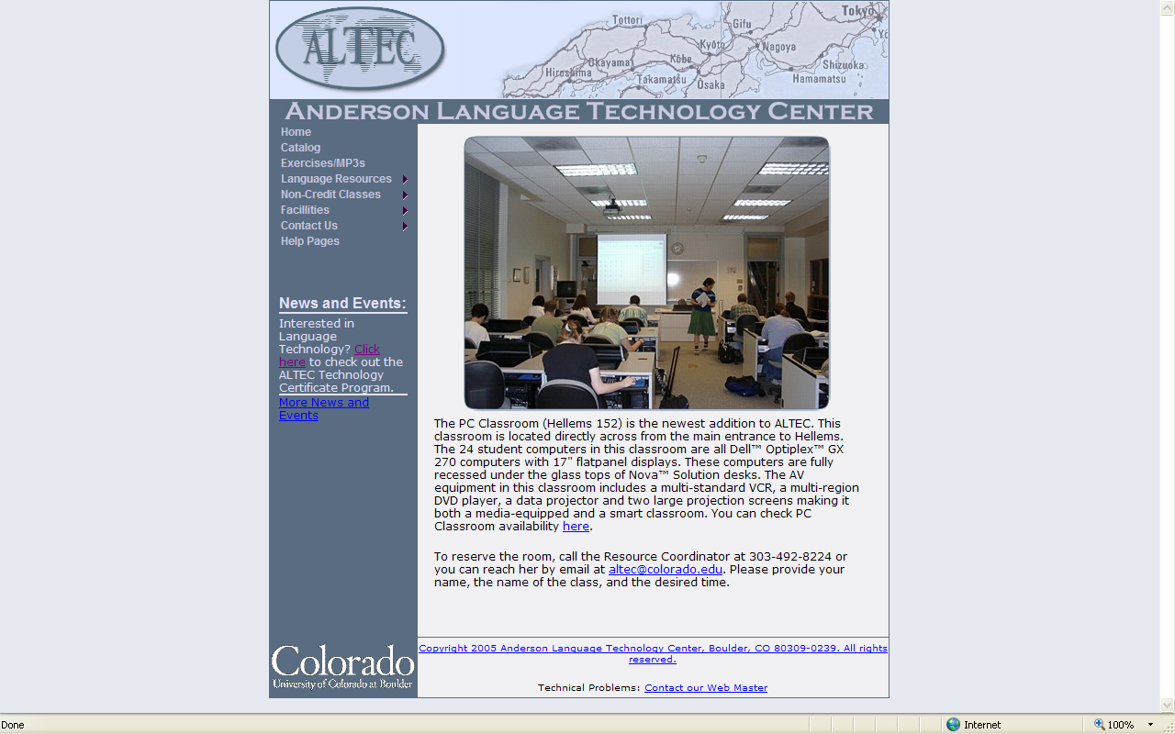

Screenshot 6 The Anderson Language Technology Center PC smart classroom

5.5 General lab related

Moreover, language labs offer additional related informational services such as: intellectual property and copyright (Yale), funding opportunities (Yale), seminars and presentations (Yale), news and announcements (Yale), mission statement (Houston), frequently asked questions (Yale), lab tour (Nebraska-Lincoln), innovation and development (Yale), research and development (Cambridge), regulations and policies (Middlesex), provision for disabled students (Middlesex), services for distance learners (Middlesex), dyslexia support (Middlesex), audio homework, audio portfolios, digital worksheets (Michigan State), computational science and engineering support (Princeton), database application services (Princeton), educational technologies center (Princeton), education and outreach services (Princeton), scholarships (Ohio State), individualised instruction (Ohio State).

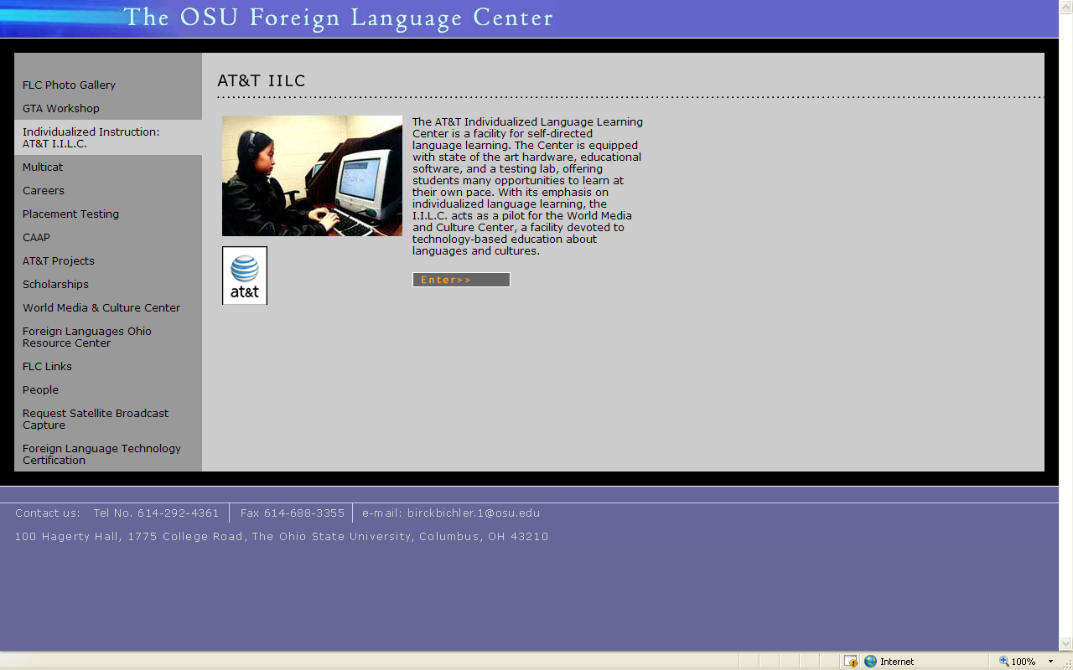

Screenshot 7 Individualized Language Learning Center

6. Conclusions

The development of recording technology since Edison’s then ground-breaking recording of a human voice on the first tinfoil cylinder phonograph in 1877 has therefore been unremitting despite the technical and financial difficulties faced by the industry’s pioneers. The relatively recent emergence of numerous wireless devices that transfer and receive information and the appearance of progressively more sophisticated e-learning platforms and authoring tools is pushing the evolution of ICT up a gear making it increasingly challenging for language labs to keep up or increasingly risky for them not to. The escalation of technological innovations however may be redounding to the benefit of those that create the technologies and is opening a Pandora’s e-box of wonders and wizardries (or possibly ‘gimmicks’ Coughlan 2007) that are now portending relatively impulsive change in language education. Some of the latest buzzwords include: moodles, virtual learning environment (VLE), course management system (CMS), learning management systems (LMS), podcatching and podcasting, video technology and applications, authoring, chatting online, chatting in 2007, Internet radio, education-oriented MOOing (e.g. SchMOOze), audio technology and applications, learning and using HTML, information on technical issues, finding where to download software, skypecasting, WebCT, blogging (vlogging), webcasting, moblogging, iPod, virtual reality (VR) environments, LAMS: learning activity management system, learning platforms, video conferencing, personal broadcasting with third generation mobile phones, augmented reality and enhanced visualisation, context-aware environments and devices, educational gaming, e-safety, blended learning (hybrid/mixed), m-learning, distributed learning, e-mentoring or e-tutoring.
Autonomous language learning is now the vogue and the construct as stated previously has a strong and persuasive theoretical underpinning; it seems the ‘autonomous learner’ and the felicitous advancements in ICT have become seemingly ideal partners for marriage. Thus language labs in this eddy of ICT change will need to make brave and thoughtful decisions regarding why new technologies should be promoted and whether the theoretical constructs for which these new technologies are supposedly suitable can be operationalised effectually. One substantive realisation for language-lab researchers in the current torrent of technological change should concern the relevance of the ‘humanware’ (Warchauer in-press). More explicitly, I mean how new technologies might strengthen the age-old and multifaceted bond between the pupil and human-teacher. Davies et al. (2005, 18) for instance, also hold a comparable view; they maintain that when considering the installation of a digital lab, ‘the first question that the modern foreign language (MFL) teacher needs to ask is to what extent the equipment is capable of enhancing tried and tested pedagogies and methodologies’.
There is also a danger in the current and innovative drive to brand-stretch key language-lab services, with the possible effect of enabling a language lab to take on a more prominent role in its educational institution, that the language lab may lose its traditional identity as a place to learn foreign languages. Moreover, it is in this area that innovative research regarding what is effective and practicable is needed. Finally, research is also required to assess, in spite of all the new lab gadgets and theoretical constructs, how prevalent audio-lingualism still is in the learning of foreign languages in modern language labs.

Word Count 3400

- References

Alexander, C. (2006). Guidelines for Internet-based teaching. Teaching English with Technology, 6(4). Retrieved November 20, 2006 from http://www.iatefl.org.pl/call/j_article26.htm#article2

Alexander, C (in press). A case study of English language teaching using the Internet in Intercollege’s language laboratory. The International Journal of Technology, Knowledge and Society, (3). Will also be available on http://ijt.cgpublisher.com/

Asher, J. (1969). The total physical approach to second language learning. Modern Language Journal, 53, 3-17.

Barnes, D. (1976). From Communication to Curriculum. London: Penguin.

Beatty, K. (2003). Teaching and Researching Computer-assisted Language Learning. Essex: Pearson Education.

Becta. (2006a). Making a difference with technology for learning: evidence for school leaders. Coventry: Becta. Retrieved May 10, 2007 from http://publications.becta.org.uk/display.cfm?resID=25961&page=1835

Becta. (2006b). Delivering the national digital infrastructure: An essential guide. Coventry: Becta. Retrieved May 10, 2007 from http://publications.becta.org.uk/display.cfm?resID=25929&page=1835

Becta. (2007a). How technology supports 14-19 reform: an essential guide. Coventry: Becta. Retrieved May 10, 2007 from http://learningandskills.becta.org.uk/display.cfm?resID=31532

Becta. (2007b). ICT and e-learning in further education: management, learning and improvement. Coventry: Becta. Retrieved May 10, 2007 from http://publications.becta.org.uk/display.cfm?resID=28534&page=1835

Benson, P. (2001). Teaching and Researching Autonomy in Language Learning. London: Longman.

Breen, M. & Candlin, C. (1980). The essentials of a communicative curriculum in language teaching. Applied Linguistics, 1(2), 89-112.

Brumfit, C. & Johnson, K. (1979). The Communicative Approach to Language Testing. Oxford: Oxford University Press.

Candlin, C. (1981). Form, function and strategy in communicative curriculum design. In C. Candlin (Ed.), The Communicative Teaching of English: Principles and an Exercise Typology (pp. 24-44). Harlow: Longman.

Chaudron, C. (1988). Second Language Classrooms: Research on Teaching and Learning. Cambridge: Cambridge University Press.

Chomsky, N. (1964). Aspects of the Theory of Syntax. Cambridge, MA: MIT Press.

Condie, R. & Munro, B. (2007). Impact of ICT in Schools—a landscape review. Coventry: Becta. Retrieved May 10, 2007 from http://publications.becta.org.uk/display.cfm?resID=28221&page=1835

Coughlan, S. (2007). Education, education, education. BBC News (online). Retrieved May 14, 2007 from http://news.bbc.co.uk/2/hi/uk_news/education/6564933.stm

Curran, C. (1976). Counseling-Learning in Second Languages. Apple River: Apple River Press.

Garcia, N. & Wolff, L. (2001). The Lowly Language Lab: Going Digital. Retrieved May 21, 2007 from http://www.techknowlogia.org/TKL_active_pages2/AboutUs/main.asp

Davies, G., Bangs, P., Frisby, R., & Walton, E. (2005). Setting up effective digital language laboratories and multimedia ICT suites for MFL. The National Centre for Languages as part of the Languages ICT initiative. Retrieved May 25, 2007 from http://www.languages-ict.org.uk/managing/digital_language_labs.pdf

The Department for Education and Skills (DfES). (2006). 2020 Vision Report of the Teaching and Learning in 2020 Review Group. The Department for Education and Skills. Retrieved May 10, 2007 from http://publications.teachernet.gov.uk/eOrderingDownload/6856-DfES-Teaching%20and%20Learning.pdf

Ellis, R. (1998). Discourse control and the acquisition-rich classroom. In W. Renandya & G. Jacobs (Eds.), Learners and Language Learning, 39: 145-71

Freire, P. (1974). Education for Critical Consciousness. London Sheed and Ward.

Gattegno, C. (1972). Teaching Foreign Languages in School: The Silent Way. NewYork: Educational Solutions.

Kelly, G. (1963). A Theory of Personality. New York: Norton.

Kilpatrick, W. (1921). The Project Method. New York: Teachers College Press.

Kolb, D. (1984). Experiential learning: Experience as the Source of Learning and Development. Englewood Cliffs, NJ: Prentice Hall.

Krashen, S. & Terrell, T. (1983). The Natural Approach: Language Acquisition in the Classroom. Oxford: Pergamon.

Little, D. (1997). Language awareness and the autonomous language learner. Language Awareness, 6(2/3), 93-104.

Lozanov, G. (1978). Suggestology and Outlines of Suggestopedy. New York: Gordon and Breach.

Nunan, D. (1992). Collaborative Language Learning and teaching. Cambridge: Cambridge University Press.

Riley, P. (1988). The Ethnography of autonomy. In A. Brookes & P. Grundy (Eds.), Individualisation and Autonomy in Language Learning (pp. 12-34). ELT Documents 131: Macmillan).

Rogers, C. (1969). Freedom to Learn. Columbus, Ohio: Charles E. Merrill.

Schoenherr, S. (2005). Recording Technology History. Retrieved May 20, 2007 from
http://history.sandiego.edu/GEN/recording/notes.html#origins

Toth, J. (2003). Language Laboratories and Archives (Chicago University). Retrieved May 20, 2007 from http://languages.uchicago.edu/old/lla.css

Vygotsky, L. (1978). Mind in Society: the Development of Higher Psychological Processes. Boston: harvard University Press.

Warschauer, M., & Healey, D. (1998). Computers and language learning: An overview. Language Teaching, 31, 57-71.

Warchauer, M. (in press). Networking the Nile: Technology and professional development in Egypt. In J. Inman & B. Hewett (Eds.), Technology and English studies: Innovative professional paths. Mahwah, N. J.: Lawrence Eribaum.

Widdowson, H. (1978). Teaching Language as Communication. Oxford: Oxford University Press.

Yalden, J. (1983). The Communicative Syllabus: Evolution, Design and Implementation. Oxford: Pergamon.

